FINASHEALTH
CREDIT ASSISTANT
AI-Powered Credit Health & Financial Wellness Platform for India
PROJECT REPORT
Submitted by: Ashlesha wankhade
Class / Branch: S.Y. AIML
College / Institution: Dr.D.Y. Patil college of engineering and innovation
Academic Year: 2026-27
Live Website: https://finashealth.web.app/
Github repository link: https://github.com/ashleshawankhade257-create/finashealth

Abstract
FinasHealth, presented as Credit Assistant, is a full-stack financial wellness and credit-intelligence platform designed for Indian retail borrowers. Its goal is to make selected credit and debt indicators easier to understand by bringing financial inputs, calculated metrics, visual summaries, progress tracking, and AI-assisted educational guidance into one web application. The platform describes CIBIL-range scores, debt-to-income ratio, credit-card utilization, and monthly savings cushion; offers an interactive what-if simulator; and uses Google Gemini 2.5 Flash to generate a structured financial assessment and debt-reduction roadmap when the AI service is configured. A deterministic rule-based fallback is also described for cases when the AI model is unavailable. The application is intended for education and financial wellness, not as an official credit bureau or lender.

1. Introduction
Credit health can affect a person's ability to access credit and manage repayments. However, financial information can be difficult to interpret when income, household expenses, loan instalments, credit-card balances, and other liabilities are considered separately. A digital tool that organizes these values and explains common indicators may help users understand their current position and consider possible next steps.
FinasHealth's Credit Assistant concept brings together a user profile, financial calculations, dashboard visualizations, progress history, and AI-assisted explanations. Users can enter their financial information, review calculated indicators, and experiment with hypothetical changes before making real-world financial decisions. The platform is designed for Indian users and uses a familiar credit-score range of 300–900 as a reference point; the app's estimates should not be confused with an official bureau score or proprietary bureau methodology.

2. Problem Statement
Many borrowers need a clearer way to understand how their monthly debt commitments, income, expenses, and credit-card balances relate to their overall financial position. Financial data may be spread across statements, apps, and personal records, while generic advice may not reflect an individual's stated circumstances. The project addresses this usability challenge by organizing user-entered financial information, calculating selected indicators, visualizing them, and providing prioritized educational suggestions in a single interface.

3. Objectives
- Build an accessible web-based financial wellness and credit-health platform.
- Provide a guided onboarding process for collecting relevant financial profile information.
- Calculate and explain debt-to-income ratio, credit-card utilization, and monthly savings cushion.
- Present credit-related information through dashboard cards, charts, and progress indicators.

Project Architecture Diagram
High-level view of the FinasHealth Credit Assistant application
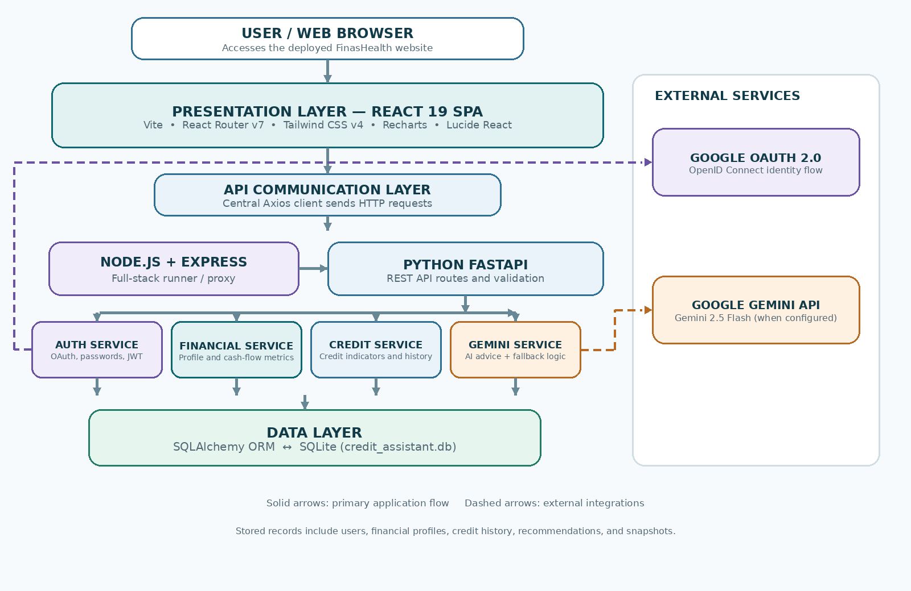
Figure 1. High-level system architecture of FinasHealth — Credit Assistant.
The React frontend communicates through Axios with the application runtime and FastAPI endpoints. Backend routers direct requests to dedicated authentication, financial, credit, and AI services. SQLAlchemy connects the application models to SQLite, while Google OAuth and Gemini are external integrations configured through environment variables. Exact request routing and live-service availability depend on deployment configuration.
- Offer an interactive what-if simulator to explore hypothetical liability or credit-limit changes.
- Generate structured, AI-assisted educational assessments and action plans when the Gemini service is configured.
- Use authentication, input validation, and server-side application layers to support account-based use.
- Document limitations clearly and encourage users to verify important decisions with qualified sources.

4. Project Scope
The project scope covers the user-facing web application and the backend services described in the README. The frontend includes landing, sign-in and registration, onboarding, dashboard, credit-health, AI-advisor, progress, profile, and settings pages. The backend includes authentication, financial profile management, credit calculations, dashboard data, and AI-advisor routes. The system is designed to store application data using SQLAlchemy and SQLite, validate API data using Pydantic, and communicate with external identity and AI services when configured.
The precise behaviour of each feature depends on the deployed configuration and working implementation. This report describes the system according to the project README supplied for documentation.

5. Target Users and Use Cases
- Retail borrowers who want to understand common debt and credit indicators.
- Users who want to compare hypothetical repayment or credit-limit scenarios.
- Users who want an organized view of their entered financial profile and progress.
- Learners exploring personal finance concepts and AI-supported financial education.
Typical use case: a user signs in, completes the financial onboarding flow, reviews their calculated indicators on the dashboard, explores the credit-health page, and consults the AI advisor for a structured educational action plan. The user can then adjust hypothetical values in the simulator to compare possible outcomes. Any action plan should be reviewed critically and should not be treated as a guaranteed credit-score outcome.

6. Key Features and Detailed Explanation

6.1 Authentication and Identity
The README describes two sign-in approaches: Google OAuth 2.0 / OpenID Connect and email-and-password authentication. The Google flow uses Google's consent and authentication process rather than asking the user to disclose a Google password to the application. For local credentials, the README describes PBKDF2-HMAC-SHA256 password hashing with 100,000 iterations and unique salts. JWT tokens are listed as part of the security stack. These mechanisms are intended to support account access and authenticated API requests; their security depends on correct configuration, secure secret management, transport security, and implementation review.
A one-click demo account is also documented for demonstration and testing. Demo credentials should be handled carefully and should never be reused for real personal information.

6.2 Guided Financial Onboarding
The 10-step onboarding wizard is designed to collect the financial inputs needed by the platform. The README lists monthly income, living expenses, credit-card sanctioned limits, total debt, active EMIs, and missed-payment information among the captured fields. Step-by-step entry can make a complex form easier to complete. Input validation is described as preventing negative income and debt values, helping reduce invalid records and calculation errors.

6.3 Core Financial Indicators
The application calculates selected indicators from user-provided data. These indicators offer a simplified snapshot of cash flow and credit use; they are not complete measures of creditworthiness.

Debt-to-Income Ratio (DTI)
DTI compares monthly debt payments with monthly gross income. A lower ratio generally means a smaller portion of income is committed to debt payments, although interpretation depends on the type of debt, income stability, household needs, and lender criteria.
Formula: DTI (%) = (Monthly Debt Payments ÷ Monthly Gross Income) × 100

Credit-Card Utilization
Credit-card utilization compares outstanding revolving balances with the total sanctioned credit-card limit. It helps users understand how much of their available revolving limit is being used.
Formula: Utilization (%) = (Outstanding Balances ÷ Total Sanctioned Limit) × 100

Monthly Savings Cushion
The monthly savings cushion estimates the amount remaining after subtracting entered living expenses and monthly EMIs from monthly income. It is a simplified estimate and may not include irregular costs, taxes, annual payments, or other obligations unless the user enters them.
Formula: Savings Cushion = Monthly Income − Monthly Expenses − Monthly EMIs
If a denominator is zero or an input is missing, the application should handle the situation safely and avoid misleading output. The exact validation and display behaviour should be confirmed in testing.

6.4 Interactive Dashboard
The dashboard is described as the main summary view. It includes a semi-circular credit-score gauge, score-change indicators, a historical score line chart, a used-versus-available revolving-credit pie chart, and metric cards with risk statuses and tips. Recharts is listed as the charting library. Visual summaries can help users identify changes and compare indicators without reading raw figures alone.
A sample score delta such as “+24 points since previous update” should be interpreted as an example or a value based on stored history, not as a promised result for every user.

6.5 AI Financial Advisor
The AI advisor is described as using Google Gemini 2.5 Flash through a dedicated service layer. The application sends structured financial data and expects a structured response containing an executive assessment, top risk factors, positive achievements, priority actions, a five-step roadmap, and monthly target milestones. Organizing the response into sections is intended to make guidance easier to read and act upon.
The README also describes a deterministic rule-based fallback when the AI model is unavailable. This fallback can help preserve basic functionality, but its recommendations may be less contextual than an AI-generated response. AI output can be incomplete or incorrect and should be treated as educational guidance rather than regulated financial advice.

6.6 What-If Credit Simulator
The simulator provides controls such as liability-paydown and credit-limit-enhancement sliders to explore hypothetical changes to selected indicators. Users can compare possible effects before deciding whether to make a real payment or request a limit change. Simulated results are mathematical estimates based on the app's assumptions; they do not guarantee a change in an official credit score, lender decision, interest rate, or loan eligibility.

6.7 Progress, Profile, and Settings
The Progress page is described as displaying score history and logging. The Profile page allows users to update financial parameters, while Settings provides account settings and a Google OAuth guide. These pages support continued use of the application as users update their information. The exact information saved and the retention rules should be reviewed against the implemented privacy and data-handling behaviour.

7. Technology Stack

Frontend
- React 19 — component-based user interface.
- Vite — development server and frontend build tooling.
- React Router v7 — client-side page navigation.
- Tailwind CSS v4 — utility-based styling and layout.
- Recharts — charts and data visualizations.
- Lucide React — interface icons.
- Axios — HTTP requests from the frontend to backend services.

Backend and Data Layer
- Python FastAPI — REST API application and service endpoints.
- Node.js Express — full-stack proxy/runner described in server.ts.
- SQLAlchemy ORM — mapping application entities to database tables.
- SQLite — relational database, identified in the README as credit_assistant.db.
- Pydantic v2 — request and response schema validation.
- PyJWT and cryptographic hashing — token handling and password-security components.
- Google Gemini API — AI-generated financial assessments when configured.
- Pytest — API test suite referenced in the project structure.

8. System Architecture
At a high level, the application can be understood as the following layers:
- Presentation layer: React pages and shared components display forms, indicators, charts, and recommendations.
- API communication layer: the Axios client sends requests to application endpoints.
- Application/API layer: Express supports the full-stack runner, while FastAPI routers handle the backend endpoints
- Business logic layer: dedicated services handle authentication, financial calculations, credit information, and Gemini integration.
- Data layer: SQLAlchemy interacts with SQLite-backed models for users, financial profiles, credit history, recommendations, and snapshots.
- External services: Google OAuth supports identity flow, and Gemini provides AI-generated content when configured.

9. Project Structure
The repository is organized into frontend pages and reusable components, backend services and API routers, data models, schemas, and tests.
src/pages/ — landing, login, registration, onboarding, dashboard, credit health, AI advisor, progress, profile, and settings pages.
- src/components/common/ — shared interface elements such as navigation, score gauge, and metric cards.
- src/context/ — authentication state and provider.
- src/services/api.ts — centralized Axios API client.
- backend/app/routers/ — authentication, users, financial, credit, dashboard, and AI endpoints.
- backend/app/services/ — authentication, financial, credit, and Gemini business logic.
- backend/app/models/ — user, financial profile, credit history, recommendation, and snapshot models.
- backend/app/schemas/ — Pydantic schemas for validation and API data structures.
- tests/test_api.py — pytest test suite referenced in the README.
- server.ts — Express full-stack runner and routing setup.

10. Application Workflow
- The user opens the FinasHealth website in a web browser.
- The user registers or signs in through an available authentication option.
- The user completes the financial onboarding steps and provides required inputs.
- The backend validates submitted data and stores relevant application records.
- Financial services calculate indicators such as DTI, utilization, and savings cushion.
- The dashboard presents calculated metrics and available historical visualizations.
- The user explores hypothetical changes in the what-if simulator.
- The AI advisor returns a structured assessment and roadmap when Gemini is configured, or the documented rule-based fallback is used.
- The user can review progress and update profile values as appropriate.

11. Security, Privacy, and Responsible Use
The website lists password hashing, OAuth-based sign-in, JWT tokens, and schema validation as security-related components. These are useful design elements, but security cannot be guaranteed by a technology list alone. The application should protect secrets and tokens, use HTTPS in production, validate permissions on protected endpoints, minimize sensitive data collection, and define appropriate data retention and deletion practices.
Financial profiles can contain sensitive personal information. Users should be told what data is collected, why it is needed, how it is stored, and how to request deletion. API keys and OAuth secrets must remain in server-side environment configuration and must not be exposed in frontend bundles or committed to a public repository.
The platform's educational disclaimer is important: Credit Assistant is not an authorized credit reporting agency such as CIBIL, Experian, Equifax, or CRIF High Mark, and it is not a bank or NBFC. The app's calculations are educational indicators, not official credit-bureau algorithms. Users should verify important lending decisions with their bank or a certified financial planner.

12. Setup and Execution
According to the README, the integrated development runner can be started with npm run dev after installing the project dependencies and configuring environment variables. The README also describes running the FastAPI backend separately using the backend requirements file and its run script.
The documented environment configuration includes Google OAuth client credentials, a redirect URI, a Gemini API key and model name, a database URL, a JWT secret key, and frontend/backend origins. Actual values must be supplied securely in a local .env file or deployment secrets manager. Do not place real secrets in the report or commit them to GitHub.
For a standalone backend, the README documents installing Python dependencies from backend/requirements.txt and launching the backend run script. It also references an interactive Swagger interface at /docs, a ReDoc interface at /redoc, and running tests with pytest tests/. These instructions should be verified against the current repository before another person follows them.

13. Website screenshots
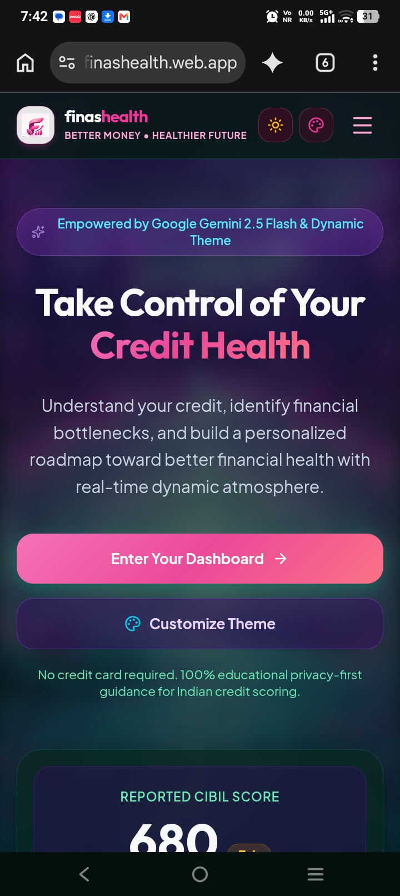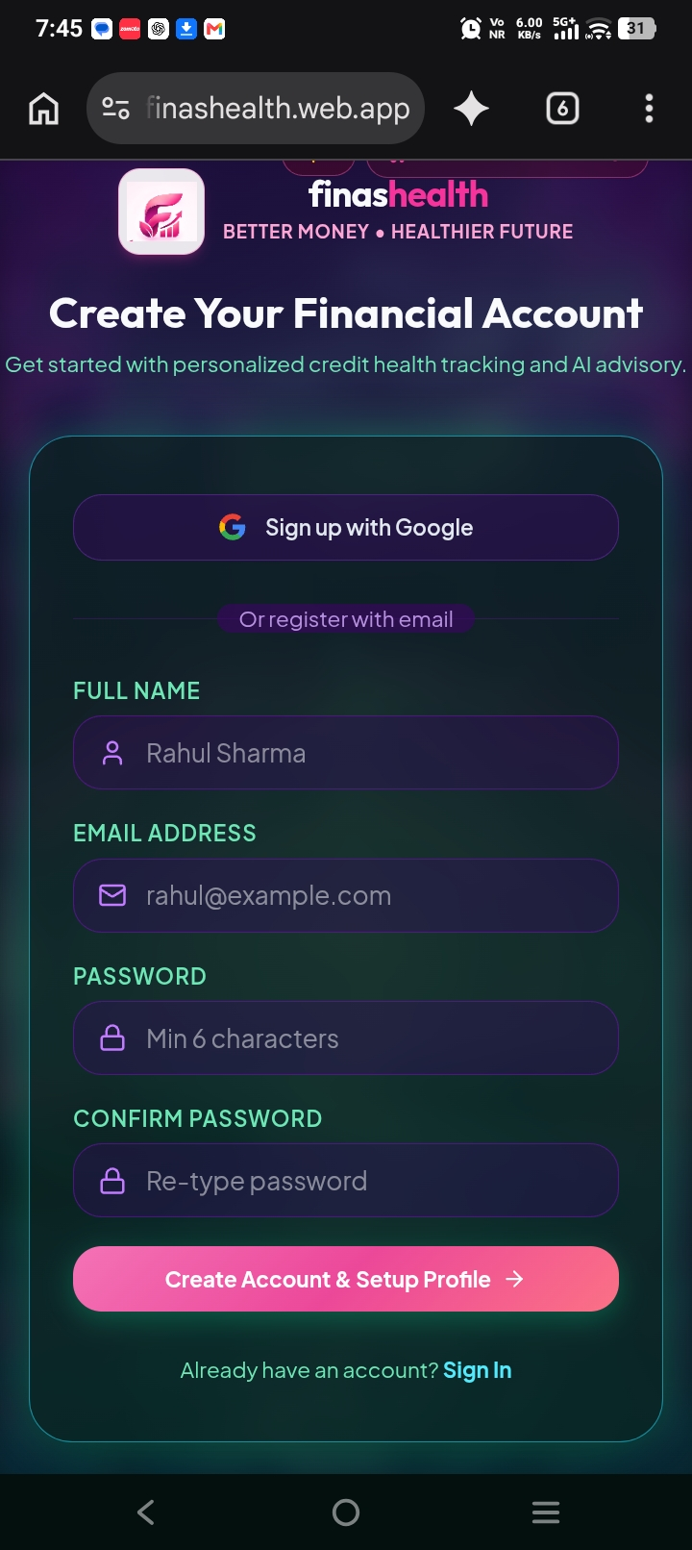

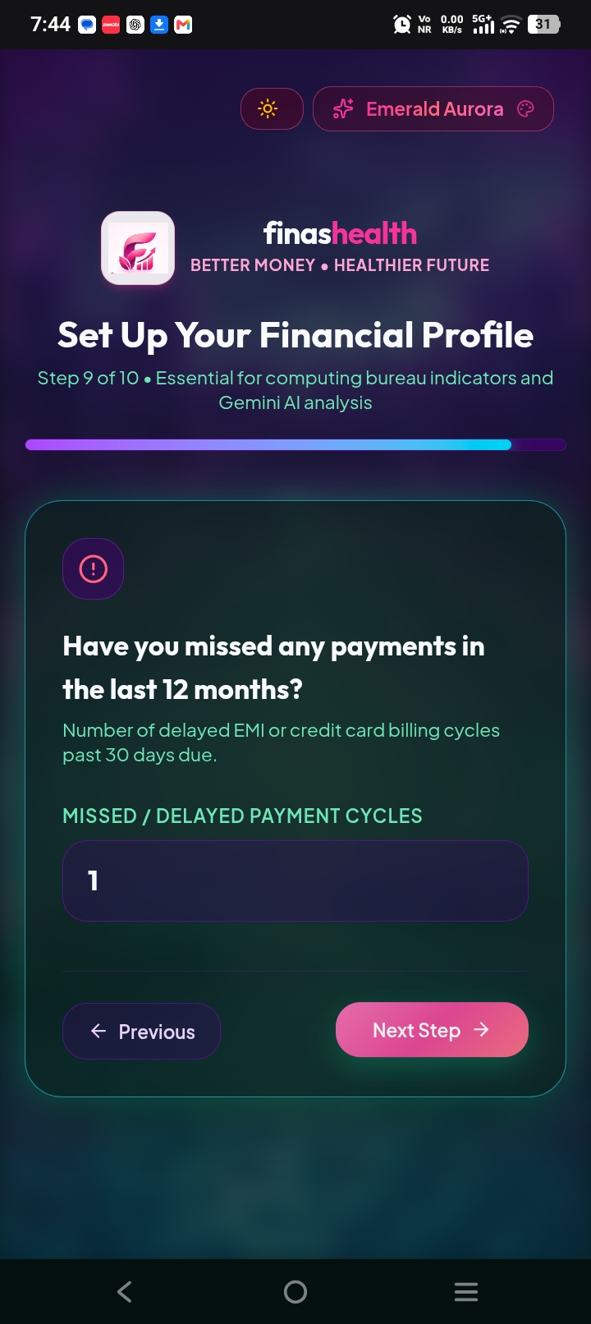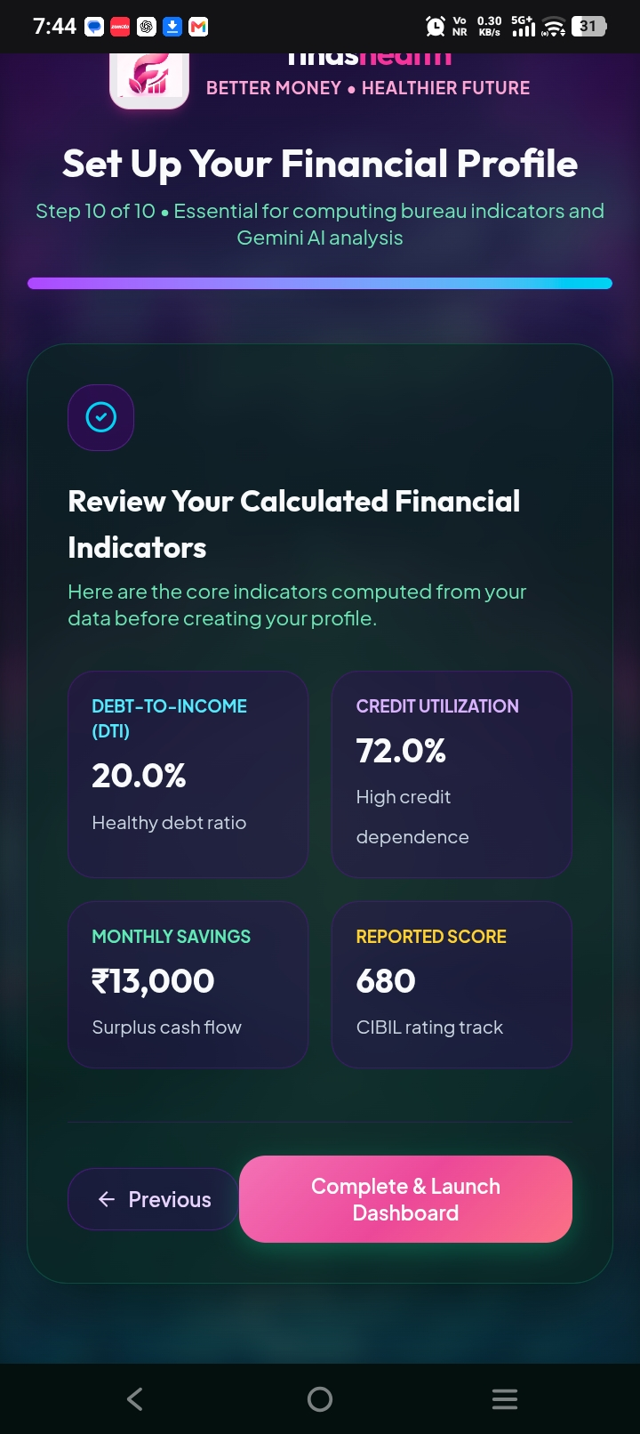

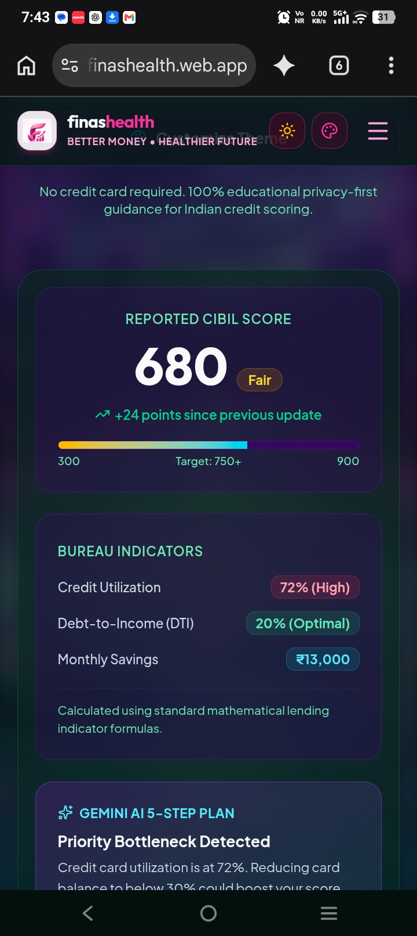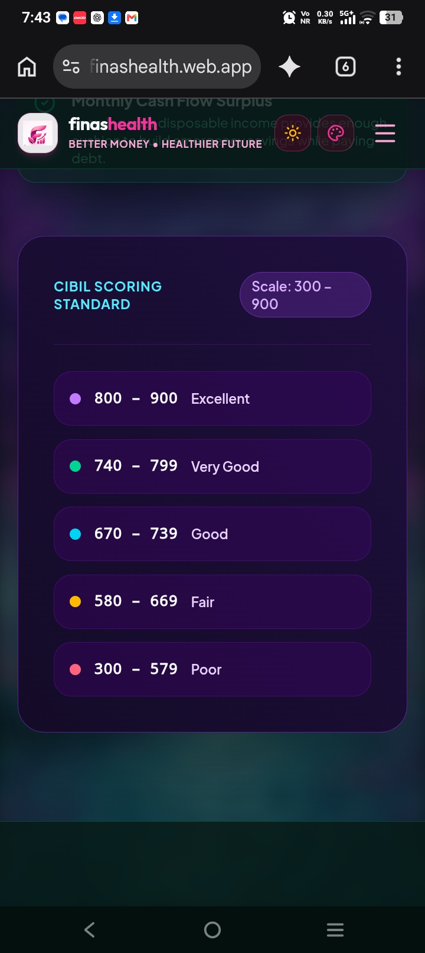

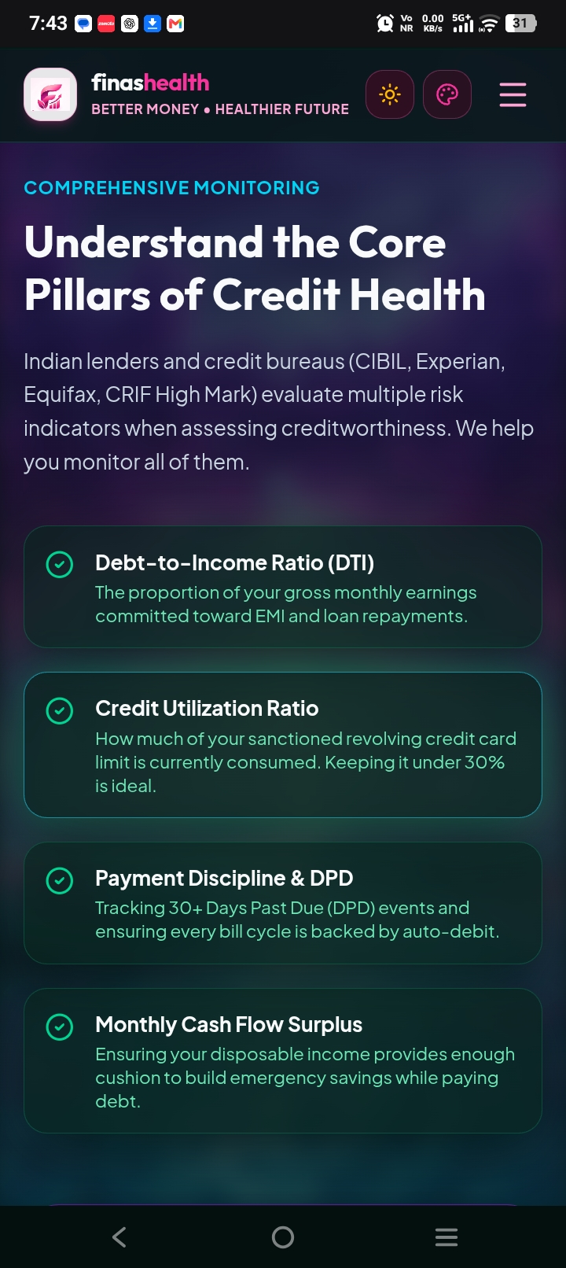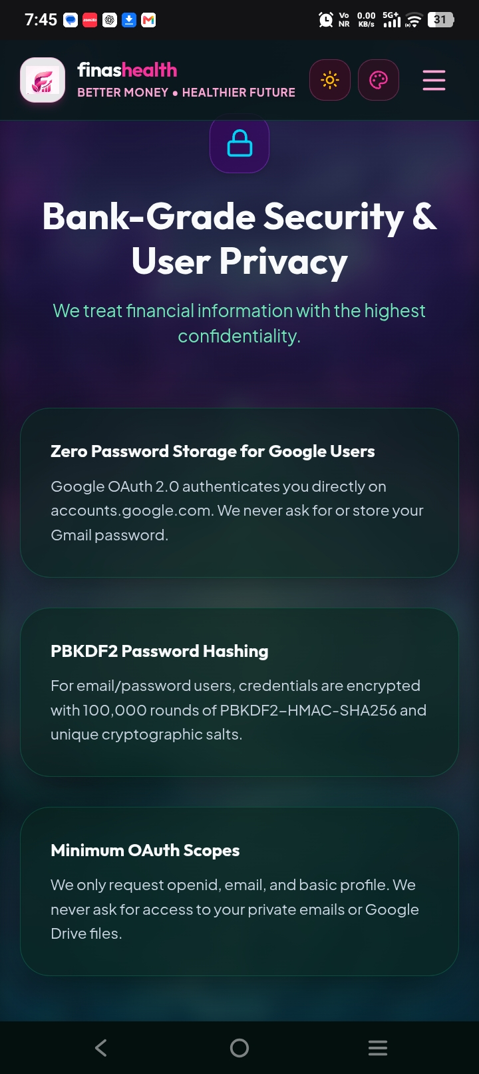

13. Limitations
- The application relies on the accuracy and completeness of the information entered by the user.
- Calculated indicators simplify a more complex financial situation and may omit factors not collected by the application.
- AI-generated guidance can be inaccurate, incomplete, or unsuitable for a particular situation.
- Simulated changes do not predict official credit-score changes or guarantee loan approval.
- Live Google OAuth and Gemini functionality depend on correct credentials, consent configuration, quotas, and network availability.
- The project is not a substitute for an official credit report or professional financial advice.

14. Future Enhancements
- Add clearer explanations and contextual help for each financial indicator.
- Improve accessibility, mobile responsiveness, and user onboarding.
- Add exportable summaries so users can review their own entered data.
- Enhance progress tracking with transparent dates, sources, and historical comparisons.
- Expand automated tests for calculations, authentication, API permissions, and error handling.
- Improve privacy controls, data export/deletion options, and security review.
- Offer multilingual educational content for a wider range of Indian users.
- Evaluate AI outputs for accuracy, consistency, safe wording, and clear disclaimers.

15. Conclusion
FinasHealth's Credit Assistant is a full-stack financial wellness platform designed to make selected credit and debt indicators easier to explore. The project combines a React-based interface, Python and Node.js backend components, structured data models, visual analytics, a hypothetical credit simulator, and an AI-assisted financial advisor. Its guided workflow and educational explanations aim to help users understand the relationship between income, debt commitments, and revolving credit use. The platform's usefulness depends on accurate inputs, careful implementation, responsible handling of financial data, and transparent limitations. It should be presented as an educational tool rather than an official credit-scoring or lending service.

16. References
- FinasHealth / Credit Assistant website: https://finashealth.web.app/

- Project README and source repository: https://github.com/ashleshawankhade257-create/finashealth

- React documentation: https://react.dev/

- FastAPI documentation: https://fastapi.tiangolo.com/

- Google Gemini API documentation: https://ai.google.dev/gemini-api/docs

- Google Identity documentation: https://developers.google.com/identity

- SQLAlchemy documentation: https://docs.sqlalchemy.org/

- Recharts documentation: https://recharts.org/

